ELT 220
Lab 9: Masking Exercise

Objectives:
This exercise should familiarized the student with the concept of masking for both isolating input bits and output bits. The exercise will also familiarize the student with the use of the setb and clr instructions.

Background information:
The diagram below is for a well control system which we will use in today's exercise as well as in several future experiments. For this exercise you will only be concerned with the tank full switch, the tank empty switch, the well pump relay and the well pump LED circuits.
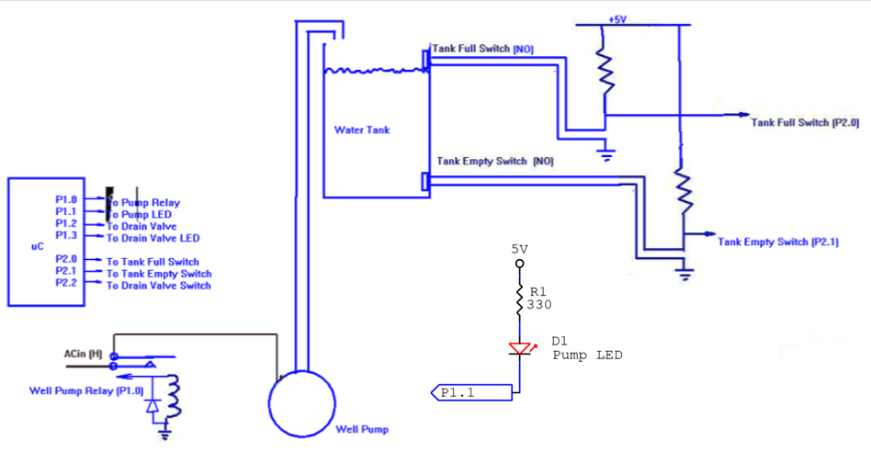

Procedure:
1. Determine whether the Tank Full Switch circuit is active High or active Low. Repeat for the Tank Empty Switch circuit.
2. Determine if a High or Low is required to energize the well pump relay, thus turning on the pump.
3. Determine whether P1.1 on the uC must be made Low or High to turn on the Pump LED.
4. Write a program which will bring port 2 into the accumulator then mask for bit 1. If bit 1 is Low, change bit 1 of port 1 to be a Low without changing any of the other bits on port 1. If bit 1 is High, change bit 1 of port 1 to be a High without changing any of the other bits on port 1. You might want to use labels for the port bits in order to avoid confusion as you write the program. You will need to use masks to do this. Once you have your program working have the proper operation of the program verified by your instructor.
5. The 8051 uC has setb and clr instructions which allow you to set and clear bits without using masks. It also has jb and jnb instructions which allow the program to jump based on the condition of a particular bit. These instructions are not found in all microcontrollers. Modify the program written in step 4 to use the jb, jnb, setb and clr instructions in place of using masks. Once you have your program working have the proper operation of the program verified by your instructor.

Report Format:
1. Cover Page
2. Program 1 .lst file (Step 4)
3. Explanation of Program 1
a. How were the mask values determined?
b. What is the logic behind the program?
i. Why were the logic (AND, OR) operations used at each point in the program?
4. Program 2 .lst file (Step 5)
5. Explanation of Program 2
a. What is the logic behind the program?
6. Comment on which method for isolating a pin you preferred and why.
7. Printout of the original handout.

One report per group
4/30/20

